**Project Design Phase-II**

**Technology Stack (Architecture & Stack)**

|  |  |
| --- | --- |
| Date | 03 Nov 2023 |
| Team ID | NM2023TMID04741 |
| Project Name | Retail Management Application Using Salesforce |

**Technical Architecture:**

The Deliverable shall include the architectural diagram as below and the information as per the table1 & table 2

**Example: Order processing during pandemics for offline mode**

**Reference:** [**https://developer.ibm.com/patterns/ai-powered-backend-system-for-order-processing-during-pandemics/**](https://developer.ibm.com/patterns/ai-powered-backend-system-for-order-processing-during-pandemics/)

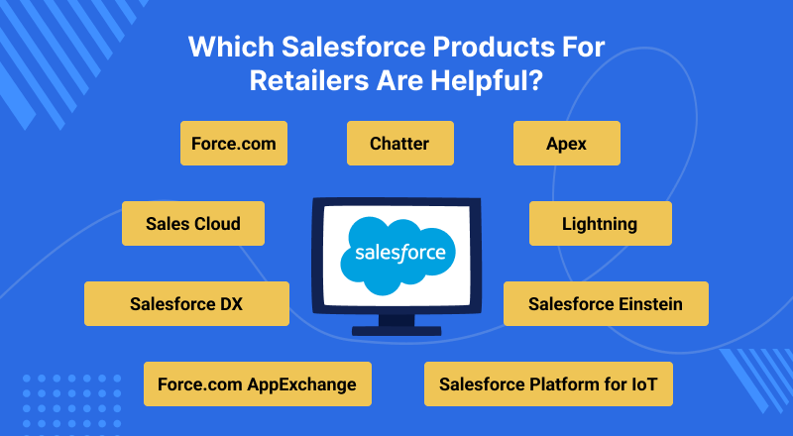

**Table-1 : Components & Technologies:**

|  |  |  |  |
| --- | --- | --- | --- |
| **S.No** | **Component** | **Description** | **Technology** |
|  | User Interface | The user interface is the component that allows users to interact with the deep learning model through a web application. | HTML, CSS, **Flask** |
|  | Application Logic-1 | Logic for a process in the application | sales |
|  | Application Logic-2 | Logic for a process in the application | IBM Watson STT service |
|  | Image pre-processing | Images can be used for classification | salesforce |
|  | Training data | To train the salesforce algorithms | Data analytics and visualization |
|  | Cloud Database | Database Service on Cloud | IBM DB2 |
|  | File Storage | File storage requirements | Utilize Salesforce's Sales Cloud for managing sales processes, leads, opportunities, and accounts. |
|  | **Hardware** | The salesforce model requires specialized hardware to perform computations efficiently | If customer support is part of your application, Service Cloud can help manage customer service requests and cases. |
|  | Convolutional neural network | start by thoroughly understanding the requirements of your retail management application. This includes understanding the specific needs of the retail business, such as inventory management, sales tracking, customer relationship management, and more. | This can include tasks such as resizing, normalization, and data augmentation. |
|  | Infrastructure (Server / Cloud) | Application Deployment on Local System | Sales |

**Table-2: Application Characteristics:**

| **S.No** | **Characteristics** | Description | **Technology** |
| --- | --- | --- | --- |
|  | Accuracy | Estimate the costs associated with developing, implementing, and maintaining the Retail Management Application. | Define data relationships and create custom objects where necessary. |
|  | Scalability | Create a detailed project plan with timelines, milestones, and responsibilities | Increasing amounts of data and user traffic without compromising performance |
|  | Ease of use | The system should be easy to use, even for users with limited technical skills. | The system should provide clear and concise instructions for users. |
|  | Flexibility | Ensure comprehensive documentation for system architecture, data models, and business processes | Implement an inventory management module that tracks stock levels, restocking, and generates alerts for low inventory. |
|  | **Security** | Develop a comprehensive testing strategy to ensure the application functions correctly and reliably. Conduct performance testing to handle peak loads during busy seasons. | This may include user authentication and encryption of data in transit and at rest. |
|  | Cost-effectiveness | Provide training for employees on how to use the system effectively.Offer ongoing support and troubleshooting resources. | The cost of using the system should be reasonable for farmers and tea plantations. |

**References:**

[**https://c4model.com/**](https://c4model.com/)

[**https://developer.ibm.com/patterns/online-order-processing-system-during-pandemic/**](https://developer.ibm.com/patterns/online-order-processing-system-during-pandemic/)

[**https://www.ibm.com/cloud/architecture**](https://www.ibm.com/cloud/architecture)

[**https://aws.amazon.com/architecture**](https://aws.amazon.com/architecture)

[**https://medium.com/the-internal-startup/how-to-draw-useful-technical-architecture-diagrams-2d20c9fda90d**](https://medium.com/the-internal-startup/how-to-draw-useful-technical-architecture-diagrams-2d20c9fda90d)